1. Summary

Sistem warehouse untuk memonitoring ketersediaan dan pengiriman stok produk (pangan, vitamin, feeder) oleh petugas warehouse untuk budidaya ikan atau udang para mitra eFishery.

1. Problem and Motivation

Masalah yang terjadi dilapangan adalah petugas warehouse sulit untuk memonitoring keluar masuknya produk yang tersedia di warehouse. Para mitra juga sulit untuk mentracking status pengiriman dan siapa pengirim produk yang di order.

1. Detailed Design

* ERD

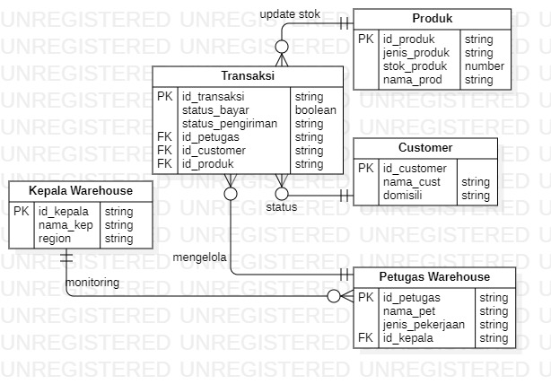

* API Contract

1. Read Petugas Table API

* Method : GET
* Endpoint : /warehouse/petugas
* Header : Authorization: Bearer <Token>
* Response Body : 200 OK

1. Create Petugas Table API

* Method : POST
* Endpoint : /warehouse/petugas/create
* Header : Authorization: Bearer <Token>
* Response Body : 200 OK

1. Update Petugas Table API

* Method : PUT
* Endpoint : /warehouse/petugas/edit/{id} => id : string
* Header : Authorization: Bearer <Token>
* Response Body : 200 OK

1. Delete Petugas Table API

* Method : DELETE
* Endpoint : /warehouse/petugas/delete/{id} => id : string
* Header : Authorization: Bearer <Token>
* Response Body : 200 OK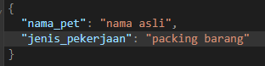

1. Read Transaksi Table API

* Method : GET
* Endpoint : /warehouse/transaksi
* Header : Authorization: Bearer <Token>
* Response Body : 200 OK

1. Read Detail Transaksi Table API

* Method : GET
* Endpoint : /warehouse/transaksi/{id} => id : string
* Header : Authorization: Bearer <Token>
* Response Body : 200 OK

1. Create Transaksi Table API

* Method : POST
* Endpoint : /warehouse/transaksi/create
* Header : Authorization: Bearer <Token>
* Response Body : 200 OK

1. Update Transaksi Table API

* Method : PUT
* Endpoint : /warehouse/transaksi/edit/{id} => id : string
* Header : Authorization: Bearer <Token>
* Response Body : 200 OK

1. Delete Transaksi Table API

* Method : DELETE
* Endpoint : /warehouse/transaksi/delete/{id} => id : string
* Header : Authorization: Bearer <Token>
* Response Body : 200 OK

